**Keypad-phone interfacing (port multiplexing)**

**Lab #06**



Spring 2022

CSE-307L Microprocessor Based system Design

Submitted by: **Ashfaq Ahmad**

Registration No: **19PWCSE1795**

Class Section: **B**

“On my honor, as student of University of Engineering and Technology, I have neither given nor received unauthorized assistance on this academic work.”

Student Signature: ______________

Submitted to:

**Dr: Aber Irfan sab**

**May** 11, 2022

**Department of Computer Systems Engineering**

**University of Engineering and Technology, Peshawar**

**Task 01:** Wire a program for a microcontroller that when you press any key from keypad, the targeted LED should on.

**Source Code:**

#include <reg51.h>

#include <stdio.h>

sbit c1=P2^2;

sbit c2=P2^1;

sbit c3=P2^0;

sbit r1=P2^3;

sbit r2=P2^4;

sbit r3=P2^5;

sbit r4=P2^6;

sbit led0=P0^0;

sbit led1=P0^1;

sbit led2=P1^0;

sbit led3=P1^1;

sbit led4=P1^2;

sbit led5=P1^3;

sbit led6=P1^4;

sbit led7=P1^5;

sbit led8=P1^6;

sbit led9=P1^7;

void main()

{

P0=P1=0x00;

r2=r3=r4=1;

r1=0;

if(c1==0)

{

led1=1;

}

else if(c2==0)

{

led2=1;

}

else if(c3==0)

{

led3=1;

}

r1=r3=r4=1;

r2=0;

if(c1==0)

{

led4=1;

}

else if(c2==0)

{

led5=1;

}

else if(c3==0)

{

led6=1;

}

r3=0;

r1=r2=r4=1;

if(c1==0)

{

led7=1;

}

else if(c2==0)

{

led8=1;

}

else if(c3==0)

{

led9=1;

}

r4=0;

r1=r2=r3=1;

if(c2==0)

{

led0=1;

}

}

**Output: (by pressing key 2 led 2 goes on)**

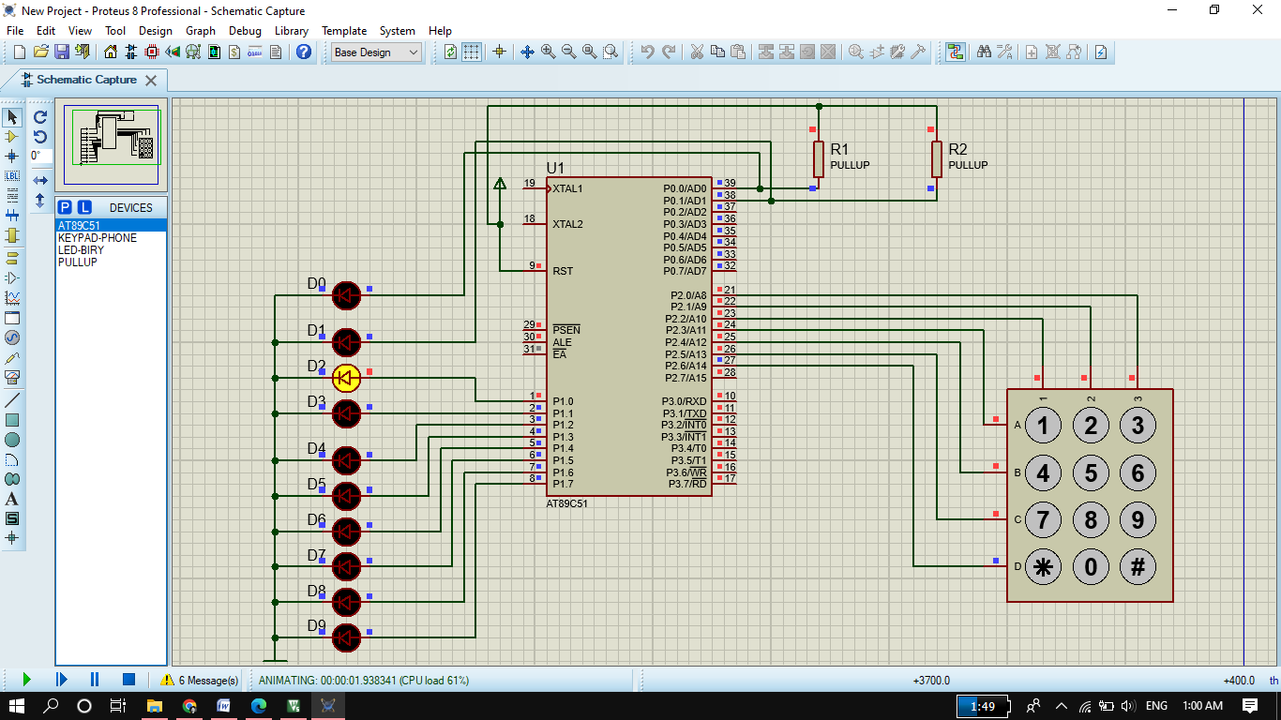

**Task02:** write the same program but in this case use 7 segments LED for output.

**Source Code:**

#include <reg51.h>

#include <stdio.h>

sbit c1=P1^0;

sbit c2=P1^1;

sbit c3=P1^2;

sbit r1=P1^3;

sbit r2=P1^4;

sbit r3=P1^5;

sbit r4=P1^6;

void main()

{

    P2=0xFF;  //active low

//all columns are initializing to 1 when we connect them and changes if we press any key but all rows are initialized to 0

//when we connect them and don't change any column if we press any key. So we initialize 3 cloumns to 1 and 1 column to 0 at a time. After that if we press any key then corresponding row and cloumn change and targetted led on.

//no need of while loop. This program is monitored by micro-controller continuously.

    r1=r2=r3=r4=1;

    r1=0;

        if(c1==0)

        {

            P2=0xF9;  //11111001

        }

        else if(c2==0)

        {

            P2=0xA4;

        }

        else if(c3==0)

        {

            P2=0xB0;

        }

    r1=r3=r4=1;

    r2=0;

        if(c1==0)

        {

            P2=0x99;

        }

        else if(c2==0)

        {

            P2=0x92;

        }

        else if(c3==0)

        {

            P2=0x82;

        }

    r3=0;

    r1=r2=r4=1;

        if(c1==0)

        {

            P2=0xF8;

        }

        else if(c2==0)

        {

            P2=0x80;

        }

        else if(c3==0)

        {

            P2=0x90;

        }

    r4=0;

    r1=r2=r3=1;

        if(c2==0)

        {

            P2=0xC0;

        }

}

**Output:**

